TASK 3:

ROLL NO:25K-0503

MUHHAMAD ABUBAKR

**Algorithm :**

1. Start program when the green flag is clicked.
2. Turn the sprite **15 degrees**.
3. Wait for **1 second**.
4. Turn the sprite **60 degrees**.
5. Wait for **1 second**.
6. Move the sprite to the **mouse pointer’s position**.
7. End.

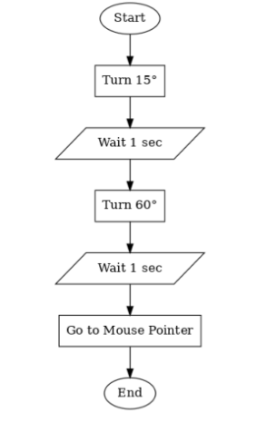

TASK 4:

**Algorithm:**

1. **Start**
2. Input temperature in **Celsius** from the user.
3. Apply the formula:  
   **Fahrenheit = (Celsius × 9/5) + 32**
4. Display the result in **Fahrenheit**.
5. **End**

TASK 5:

**Algorithm: Simple Calculator (Addition)**

1. **Start**
2. Input the **first number**.
3. Input the **second number**.
4. Add the two numbers:  
   **Sum = Number1 + Number2**
5. Display the result (Sum).
6. **End**

TASK 6**: PROGRAM**

#include <stdio.h>

int main() {

char name[50];

printf("Enter your name: ");

scanf("%s", name);

printf("Hello, %s!\n", name);

return 0;

}

TASK 7: **PROGRAM**

#include<stdio.h>

int main() {

int sub1, sub2, sub3, total;

float percentage;

printf("Enter marks for Subject 1: ");

scanf("%d", &sub1);

printf("Enter marks for Subject 2: ");

scanf("%d", &sub2);

printf("Enter marks for Subject 3: ");

scanf("%d", &sub3);

total = sub1 + sub2 + sub3;

percentage = (total / 300.0) * 100;

printf("\total Marks = %d", total);

printf("\Percentage = %.2f%%\n", percentage);

return 0;

}

TASK 8:

**Cat Moves 10 Steps Forward:**

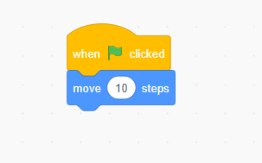

TASK 9:

**Sprite Dance Animation**

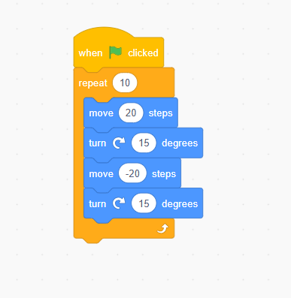

TASK 10:

**Talking Sprite**

